**HANDSON EXERCISES - WEEK 2**

**Skill : PL/SQL**

**Exercise 1: Control Structures**

**Scenario 1:** The bank wants to apply a discount to loan interest rates for customers above 60 years old.

**Question 1 :** Write a PL/SQL block that loops through all customers, checks their age, and if they are above 60, apply a 1% discount to their current loan interest rates.

**CODE :**

BEGIN

FOR cust IN (SELECT CustomerID, DOB FROM Customers) LOOP

DECLARE

v_age NUMBER;

BEGIN

SELECT FLOOR(MONTHS_BETWEEN(SYSDATE, cust.DOB) / 12)

INTO v_age

FROM dual;

IF v_age > 60 THEN

UPDATE Loans

SET InterestRate = InterestRate - 1

WHERE CustomerID = cust.CustomerID;

DBMS_OUTPUT.PUT_LINE('Discount applied for Customer ID: ' || cust.CustomerID || ', Age: ' || v_age);

END IF;

END;

END LOOP;

COMMIT;

END;

/

**OUTPUT :**  
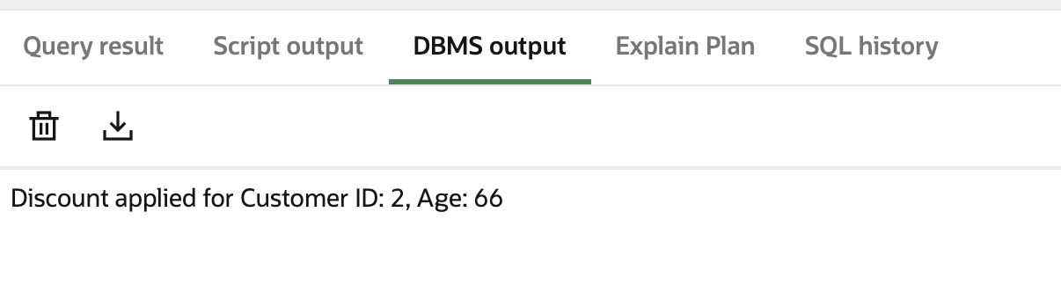

SELECT * FROM Loans;

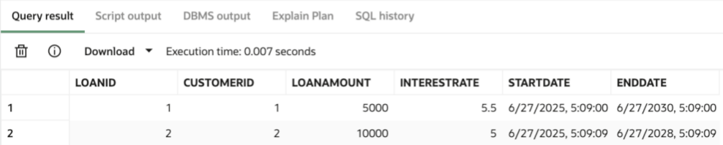

**Scenario 2 :** A customer can be promoted to VIP status based on their balance.

**Question:** Write a PL/SQL block that iterates through all customers and sets a flag IsVIP to TRUE for those with a balance over $10,000.

**CODE :**

BEGIN

FOR cust IN (SELECT CustomerID, Name, Balance FROM Customers) LOOP

IF cust.Balance > 10000 THEN

UPDATE Customers

SET IsVIP = 'TRUE'

WHERE CustomerID = cust.CustomerID;

DBMS_OUTPUT.PUT_LINE('Customer ' || cust.Name || ' (ID: ' || cust.CustomerID || ') promoted to VIP.');

ELSE

UPDATE Customers

SET IsVIP = 'FALSE'

WHERE CustomerID = cust.CustomerID;

END IF;

END LOOP;

COMMIT;

END;

/

**OUTPUT :**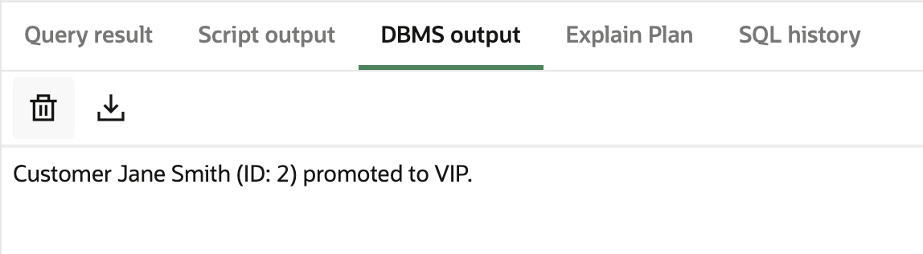

SELECT CustomerID, Name, Balance, IsVIP FROM Customers;

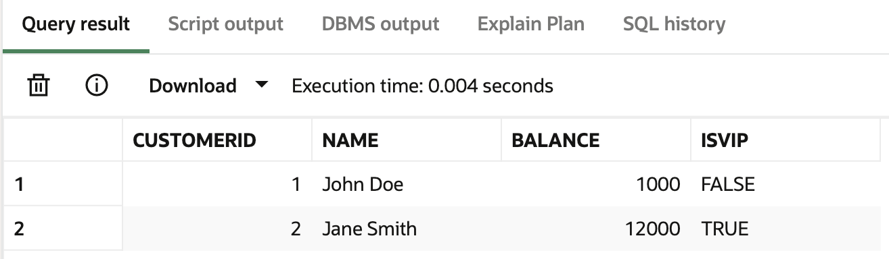

**Scenario 3 :** The bank wants to send reminders to customers whose loans are due within the next 30 days.

**Question:** Write a PL/SQL block that fetches all loans due in the next 30 days and prints a reminder message for each customer.

**CODE :**

UPDATE Loans SET EndDate = SYSDATE + 10 WHERE LoanID = 2;

**After updating ,**BEGIN

FOR loan_rec IN (

SELECT l.LoanID, l.CustomerID, l.EndDate, c.Name

FROM Loans l

JOIN Customers c ON l.CustomerID = c.CustomerID

WHERE l.EndDate BETWEEN SYSDATE AND SYSDATE + 30

) LOOP

DBMS_OUTPUT.PUT_LINE(

'Reminder: Loan ID ' || loan_rec.LoanID || ' for customer ' || loan_rec.Name ||

' is due on ' || TO_CHAR(loan_rec.EndDate, 'DD-MON-YYYY')

);

END LOOP;

END;

/

**OUTPUT :**

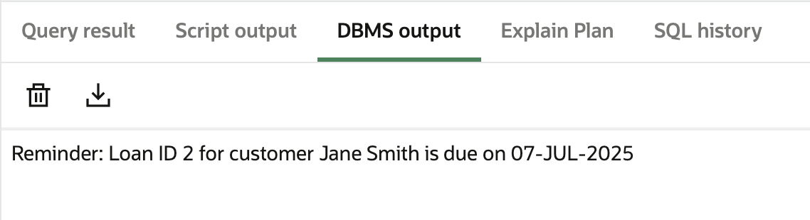

**Exercise 3: Stored Procedures**

**Scenario 1 :** The bank needs to process monthly interest for all savings accounts.

**Question:** Write a stored procedure **ProcessMonthlyInterest** that calculates and updates the balance of all savings accounts by applying an interest rate of 1% to the current balance.

**CODE :**

**Creating a Procedure**

CREATE OR REPLACE PROCEDURE ProcessMonthlyInterest IS

BEGIN

FOR acc IN (

SELECT AccountID, Balance

FROM Accounts

WHERE AccountType = 'Savings'

) LOOP

UPDATE Accounts

SET Balance = Balance + (acc.Balance * 0.01)

WHERE AccountID = acc.AccountID;

DBMS_OUTPUT.PUT_LINE(

'1% interest added to Account ID: ' || acc.AccountID ||

', New Balance: ' || TO_CHAR(acc.Balance * 1.01, '9999.99')

);

END LOOP;

COMMIT;

END;

/

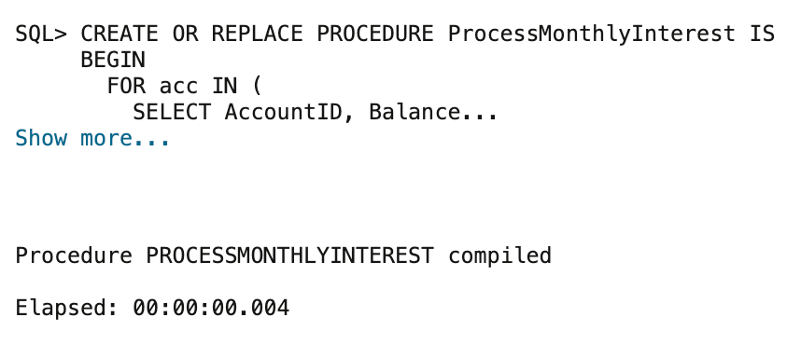

**Running the Procedure :**BEGIN

ProcessMonthlyInterest;

END;

/

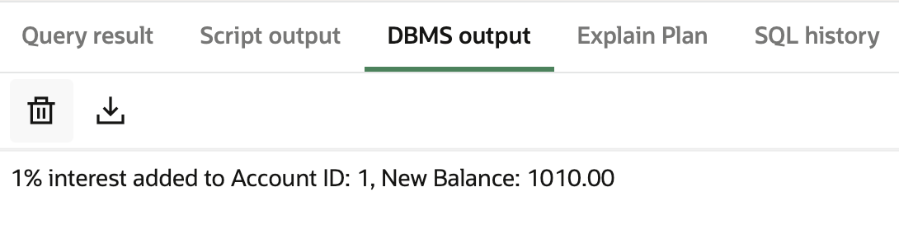

SELECT AccountID, Balance FROM Accounts WHERE AccountID = 1;

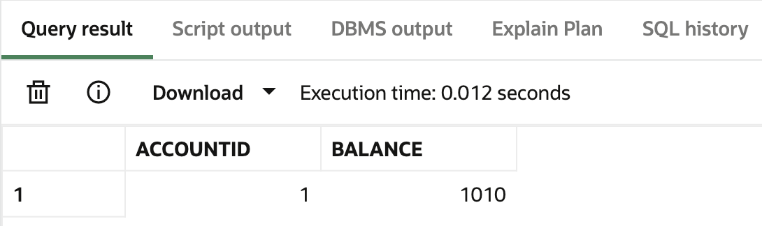

**Scenario 2 :** The bank wants to implement a bonus scheme for employees based on their performance.

**Question:** Write a stored procedure **UpdateEmployeeBonus** that updates the salary of employees in a given department by adding a bonus percentage passed as a parameter.

**CODE :**

**Creating a Procedure**

CREATE OR REPLACE PROCEDURE UpdateEmployeeBonus(

p_dept IN VARCHAR2,

p_bonus_percent IN NUMBER

) IS

BEGIN

FOR emp IN (

SELECT EmployeeID, Name, Salary

FROM Employees

WHERE Department = p_dept

) LOOP

UPDATE Employees

SET Salary = Salary + (emp.Salary * (p_bonus_percent / 100))

WHERE EmployeeID = emp.EmployeeID;

DBMS_OUTPUT.PUT_LINE(

'Bonus of ' || p_bonus_percent || '% applied to ' || emp.Name ||

' (ID: ' || emp.EmployeeID || '), New Salary: ' ||

TO_CHAR(emp.Salary * (1 + p_bonus_percent / 100), '999999.99')

);

END LOOP;

COMMIT;

END;

/

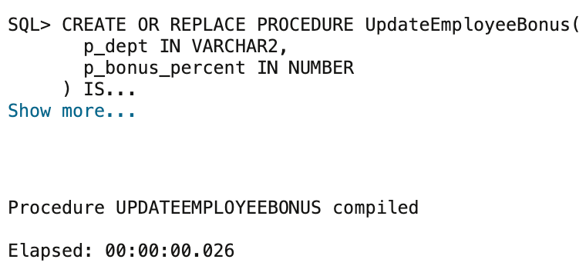

**Running the Procedure :**

BEGIN

UpdateEmployeeBonus('IT', 10);

END;

/

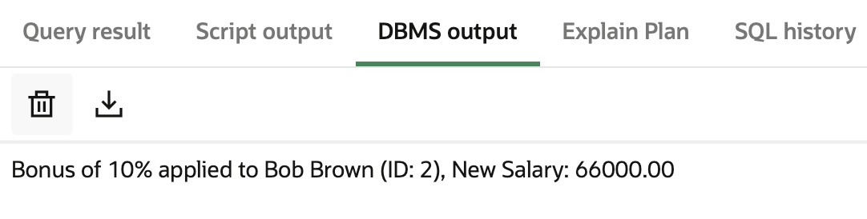

SELECT Name, Salary FROM Employees WHERE EmployeeID = 2;

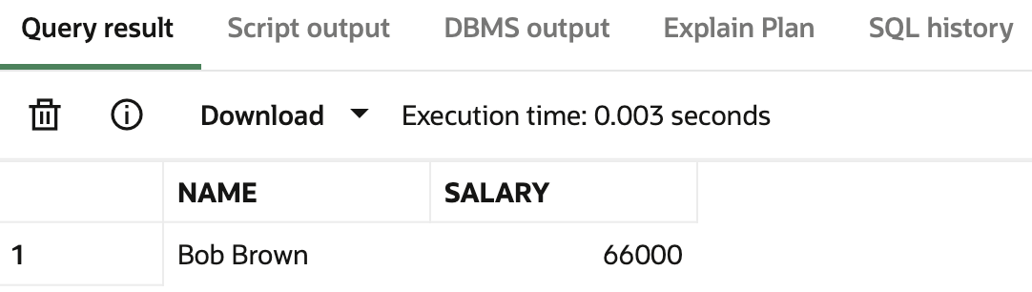

**Scenario 3 :** Customers should be able to transfer funds between their accounts.

**Question:** Write a stored procedure **TransferFunds** that transfers a specified amount from one account to another, checking that the source account has sufficient balance before making the transfer.

**CODE :**

**Creating a Procedure**

CREATE OR REPLACE PROCEDURE TransferFunds(

p_from_account_id IN NUMBER,

p_to_account_id IN NUMBER,

p_amount IN NUMBER

) IS

v_from_balance NUMBER;

BEGIN

SELECT Balance INTO v_from_balance

FROM Accounts

WHERE AccountID = p_from_account_id;

IF v_from_balance >= p_amount THEN

UPDATE Accounts

SET Balance = Balance - p_amount

WHERE AccountID = p_from_account_id;

UPDATE Accounts

SET Balance = Balance + p_amount

WHERE AccountID = p_to_account_id;

DBMS_OUTPUT.PUT_LINE('Transfer of ₹' || p_amount || ' successful from Account ' || p_from_account_id || ' to Account ' || p_to_account_id);

ELSE

DBMS_OUTPUT.PUT_LINE('Insufficient funds in Account ' || p_from_account_id);

END IF;

COMMIT;

EXCEPTION

WHEN NO_DATA_FOUND THEN

DBMS_OUTPUT.PUT_LINE('One of the accounts does not exist.');

WHEN OTHERS THEN

DBMS_OUTPUT.PUT_LINE('An unexpected error occurred: ' || SQLERRM);

END;

/

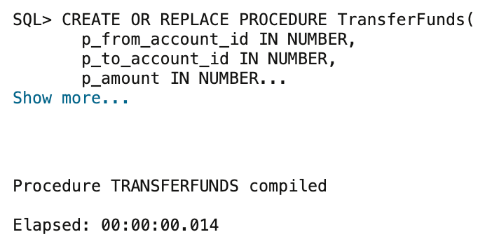

**Running the Procedure :**

BEGIN

TransferFunds(2, 1, 200);

END;

/

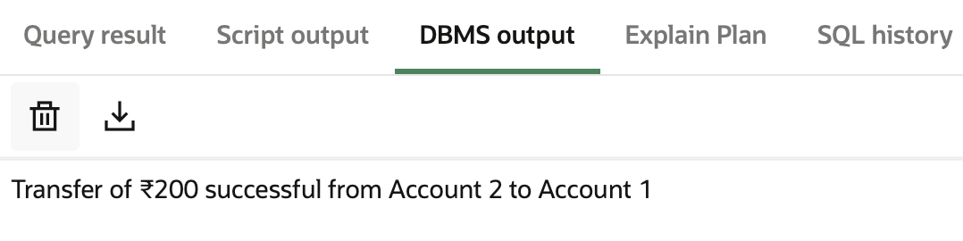

SELECT AccountID, Balance FROM Accounts;

